H.T No
Regulations:
A18

Sreenidhi Institute of Science and Technology
(An Autonomous Institution)
Code No: 7C405 Date: 19-Mar-2021 (AN)

B.Tech II-Year II- Semester External Examination, March/April - 2021 (Supplementary)
ANALOG CIRCUITS (EEE, ECE and ECM)

Time: 3 Hours Max.Marks:70

Note: a) No additional answer sheets will be provided.
b) All sub-parts of a question must be answered at one place only, otherwise it will not be valued.
c) Missing data can be assumed suitably.

ANSWER ANY 5 OUT OF 8 QUESTIONS. EACH QUESTION CARRIES 14 MARKS.

Bloom's Cognitive Levels of Learning (BCLL)

Remember | L1 | Apply | L3 | Evaluate | L5
Understand | L2 | Analyze | L4 | Create | L6

 |  |  | BCLL | CO(s) | Marks
1. | a) | Draw and explain the operation of Class AB power amplifier. | L2 | CO1 | [7M]
 | b) | Explain the operation of complementary symmetry power amplifier. | L2 | CO1 | [7M]
2. | a) | Explain about tapped single tuned capacitance coupled amplifier. | L2 | CO2 | [7M]
 | b) | Describe the operation of synchronous tuned amplifiers and state its demerits. | L2 | CO2 | [7M]
3. | a) | Design a biased clipper circuit that implements the following voltage transfer characteristics: (Assume ideal diode)  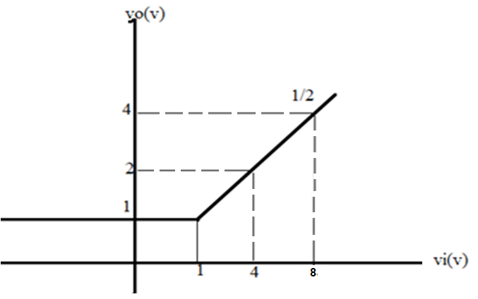 | L3 | CO3 | [7M]
 | b) | Compare and contrast positive and negative clamper circuits. | L4 | CO3 | [7M]
4. | a) | Design a bistable multivibrator to meet the following specifications: V_{cc}=V_{BB} = 12V, I_{c}(sat) = 6mA, h_{FE}(min) = 25, Maximum trigger frequency = 25KHz. Assume V_{CE}(sat) = 0.4V, V_{BE}(sat) = 0.8V. | L3 | CO4 | [7M]
 | b) | Draw the circuit and explain the operation of collector coupled monostable multivibrators. | L2 | CO4 | [7M]
5. | a) | Explain the operation of Miller time base generator. | L2 | CO5 | [7M]
 | b) | Draw and explain current sweep transistor current time base generator. | L2 | CO5 | [7M]
6. | a) | Explain about bidirectional sampling gate using transistors. | L2 | CO6 | [7M]
 | b) | Draw the circuit diagram of 2-input NAND gate using TTL and RTL and compare the two circuits in terms of ease of implementation and speed. | L4 | CO6 | [7M]
7. | a) | Write short note on harmonic and cross over distortion. Also mention the techniques to eliminate these distortions. | L2 | CO1 | [5M]
 | b) | Find the value of Inductor in an LC single tuned amplifier with the following specifications:  Resonance frequency, f_{r} = 5KHz , C= 0.01µF | L3 | CO2 | [5M]
 | c) | Draw the response of RC low pass circuit for step and pulse inputs. | L2 | CO3 | [4M]
8. | a) | For the astable multivibrator shown in Figure below, R₁=R₂=R=47kΩ, C₁=C₂=C=0.01μF. Find the time period and frequency of the square wave generated.  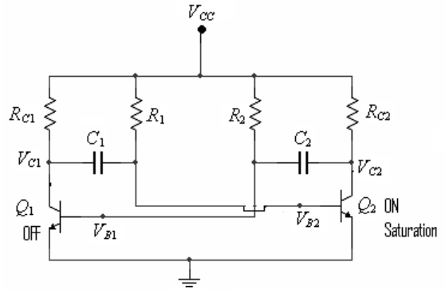 | L3 | CO4 | [5M]
 | b) | List the general features of time base signals. | L1 | CO5 | [5M]
 | c) | Explain the operation of unidirectional sampling gate using diodes. | L2 | CO6 | [4M]

-- 00 -- 00 –

